|  |  |
| --- | --- |
| Stella Nova Logo | LOGO4 |
| Best Buy Canada Mobile | |
| |  | | --- | | **Price Check Feature Document** |   **Document Version: 1.2**  **Date: August 26, 2014** | |
| **Prepared By: Amy Byers** | |
|  | |

**Table of Contents**

*1.* *Feature Overview* 3

1.1 Feature Description 3

1.2 Assumptions 3

1.3 Parameters and System Settings 3

1.4 Interfaces 3

*2.* *USE CASE: Price Check* 4

2.1 Feature Flow 4

2.2 Precondition 4

2.3 Main Flow 4

2.4 Alternate Flows 5

2.5 Post Condition 5

2.6 Special Requirements 5

*3.* *Supplemental Specifications* 5

3.1 Electronic Journal 5

3.2 Operator Sign On Feature 5

3.3 POSLog 5

3.4 Sale Feature 5

*4.* *Screen Layouts* 5

4.1 Price Check 5

*5.* *Revision History* 8

6. Appendix A: Source Documentation 8

6.1 Functional Requirements 8

*7.* *Appendix A: Glossary* 8

# *Feature Overview*

## Feature Description

One of the many benefits with having a mobile POS application is the ability to check the price of an item on the spot versus requiring customer to take the item to a price check station. This additional flexibility provides on the spot price checks without requiring the operator to log into the mobile POS application.

## Assumptions

1. Item information can be scanned or manually entered on the mobile device
2. Scanning is an implied enter.
3. The Not on File use case cannot be executed from the Price Check use case.
4. The system accepts UPC as a valid entry.

## Parameters and System Settings

|  |  |  |
| --- | --- | --- |
| **Parameter Mnemonic** | **Description** | **Valid Values** |
| Allow Price Check | Determines, by mobile device, if the Price Check option is displayed on the Operator Sign On screen. | * On * Off |
| Add Price Check Item to Transaction | Determines if the option to add a price check item to the transaction is available during the Price Check process. | * On * Off |
| Display Total Price of Item with Mandatory Linked Items | Determines if the location requires the displaying of the full price of the product when displaying the price during Inventory Lookup or Price Check. The full price will include any mandatory linked items that defined in the database – this does not include any mandatory-optional related item setup. | * On * Off |

## Interfaces

|  |  |
| --- | --- |
| **Interface** | **Description** |
| Stella Nova Item Lookup Service | Service that returns item information |

# *USE CASE: Price Check*

## Feature Flow



## Precondition

* Allow Price Check is enabled.
* Add Price Check Item to Transaction is enabled.
* The operator has selected the Price Check option from the Operator Sign-On screen.

## Main Flow

1. The system prompts the operator to enter item information.
2. The operator enters the item information and accepts the entry.
3. The system sends a message to the Item Lookup Service to retrieve the current selling price for the item.
4. The system receives a response.
5. If the item is not found, the system displays a message; the operator acknowledges the message and the system restarts the Main Flow.
6. The system displays item details and prompts the operator to add the item to the basket or price check another item.
7. If the operator selects to end the process, the use case ends and the system returns to the calling use case.
8. If the operator selects to price check another item, the system restarts the Main flow.
9. The operator selects to add the item to a transaction, the system executes the Operator Sign-On use case, adds the item and the use case ends.

## Alternate Flows

None

## Post Condition

* Item price information is retrieve for the item number entered.

## Special Requirements

1. If item information is found, the system displays all available item information including but not limited to item number, item description (long or short), quantity on hand and item price.
2. The system does not save any item information when the Price Check process is ended without adding the item to a transaction.
3. The operator must sign into the application to add the price check item to the transaction
4. A transaction is initiated by selecting to add a price check item to a transaction.
5. Offline responses from the item Lookup Service is treated as item not found.

### Special Offline Requirements

None

### Data Input/Output

|  |  |  |
| --- | --- | --- |
| **Data Element** | **Description** | **Destination** |
| None |  |  |

# *Supplemental Specifications*

## Electronic Journal

Electronic journal mockups for this feature are documented in the Electronic Journal document.

## Operator Sign On Feature

The Operator Sign-On use case is executed when the operator selects to add the price checked item to a transaction.

## POSLog

POSLog mockups for this feature are documented in the POSLog document.

## Sale Feature

The Sale Feature use case is updated to reflect that an item can be added to a transaction (initiating a transaction) from the Price Check feature.

# *Screen Layouts*

## Price Check

The system displays this screen when the operator selects the Price Check option from the Operator Sign-On screen. The ability to price check an item is based on a parameter. Once a price check is successful, the screen is updated and the item information for the price checked item. The operator has the option to add the current item to the transaction, price check another item, or return to the Operator Sign-On screen. If the operator selects to add the item to the transaction, the Operator Sign-On use case is executed prior to creating a transaction and adding the item to the transaction.

If the Display Total Price of Item with Mandatory Linked Items parameter is enabled, then the system will check if the item to be displayed has any mandatory items (such as recycle fee, not a mandatory-optional selection list) associated with it that has a price greater than $0.00. If mandatory items exist, the system displays a Total Price line along with additional lines of data with a short description for each item (main item and each additional mandatory items).

### Mockup

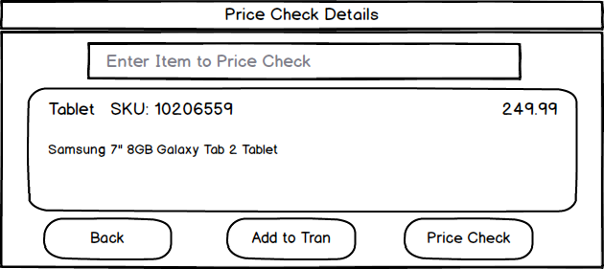

Figure 1: Price Check Results without Additional Fee and Total Price

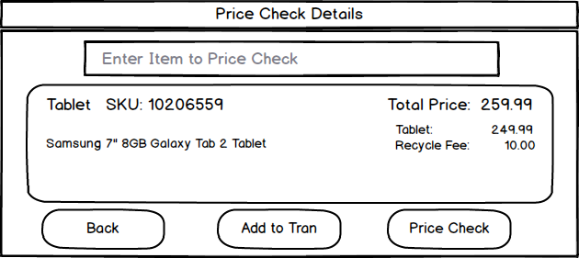

Figure 2: Price Check Results with Additional Fee and Total Price

### Instruction Text

|  |
| --- |
| **Instructions** |
| None |

### Navigation/Menu Key

|  |  |  |  |
| --- | --- | --- | --- |
| **Label** | **State** | **Next Screen** | **Notes** |
| Back | Enabled | Operator Sign-On use case | None |
| Add to Tran | Enabled | Operator Sign-On use case | Operator sign on required to initiate a transaction and then item added to the transaction. |
| Price Check | Enabled | * Item not found: Item Not Found * Item found: Price Check | None |

### Data/Input Field

|  |  |  |  |  |  |  |
| --- | --- | --- | --- | --- | --- | --- |
| **Label** | **Editable** | **Req’d?** | **Data Type** | **Min**  **Length** | **Max**  **Length** | **Notes** |
| Enter item to price check. | Yes | No | Numeric | 1 | 8 | Focus in field when screen displays for user. |
| Item Name | No | N/A | N/A | N/A | N/A | Display only when item is present |
| Item Number | No | N/A | N/A | N/A | N/A | Display only when item is present |
| Item Unit Price | No | N/A | N/A | N/A | N/A | * Display if parameter is disabled to included mandatory items within the display price. * Display only when item is present The dollar sign symbol ‘$’ is displayed with the price * Current selling price for the item. |
| Total Price  With individual item lines | No | N/A | N/A | N/A | N/A | * Display if parameter is enabled to included mandatory items within the display price. * The value represents the summation of current selling price for the price checked item and all its mandatory items associated with it. * Listing of the item with its current selling price along with each mandatory item with its current selling price. |
| Item Description | No | N/A | N/A | N/A | N/A | * Display only when item is present * Long Description associated with the item includes Specific details about the item. e.g. color, size, etc. |
| Quantity on Hand | No | N/A | N/A | N/A | N/A | * Available quantity on hand for item * Display only when item is present |

### Reason Code

|  |  |  |
| --- | --- | --- |
| **Reason Code** | **Valid Values** | **Default Value** |
| None |  |  |

### Info Not Found

|  |  |
| --- | --- |
| **Description** | This message is displayed when the system is unable to retrieve any item information for the item number entered. When the operator acknowledges the message, the system returns to the previous screen and prompts the operator to enter the item information. **Note:** If the information was entered manually, the previous information is removed from the item number field. |
| **Message** | Information not found. |
| **Key prompt** | OK |
| **Notes** | Configurable message |

# *Revision History*

|  |  |  |  |
| --- | --- | --- | --- |
| **Reviser** | **Revision** | **Date** | **Version** |
| Amy Lackas | Initial version created | 03/21/2013 | 1.0 |
| Amy Lackas | Updates screenshot | 04/24/2013 | 1.1 |
| Amy Byers | Added Requirements & references | 08/26/2014 | 1.2 |

# *Appendix : Source Documentation*

* Requirement Specification - XPOS

## Functional Requirements

|  |  |  |  |  |
| --- | --- | --- | --- | --- |
| **ID** | **Category** | **Sub-Category** | **Description** | **Section(s)** |
| 2.1 | Functions | Price Check | Once the Price Check function is launched, the cursor will be placed in the text box, allowing the user to begin typing. | * 4.1.4 Data/Input Field |
| 2.3 | Functions | Price Check | The ability to add the price checked SKU to a transaction will remain. | * 2.3 Main Flow * 2.6 Special Requirements * 3.2 Operator Sign On Feature * 4.1 Price Check * 4.1.3 Navigation/Menu Key |

# *Appendix A: Glossary*

|  |  |
| --- | --- |
| **Term** | **Definition** |
| Quantity on Hand | Also known as QoH or QOH, is the quantity available for purchase at any given location, typically a store |